15. ReactJS-HOL:
Create a react app with the name “ticketraisingapp” & open it in the vs code.
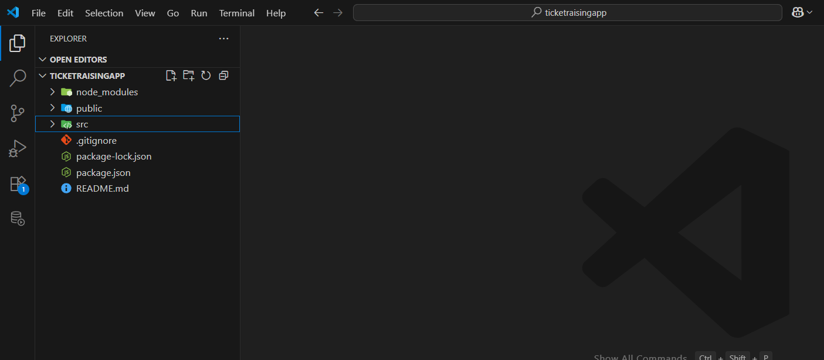
App Component:
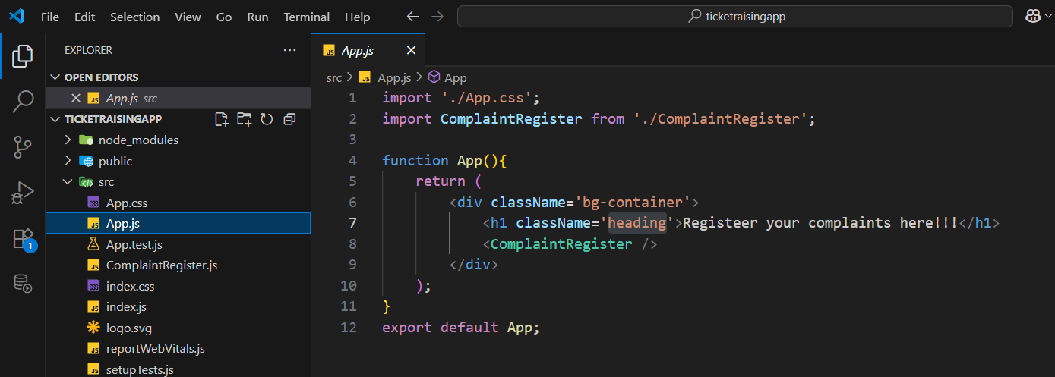
App.css:
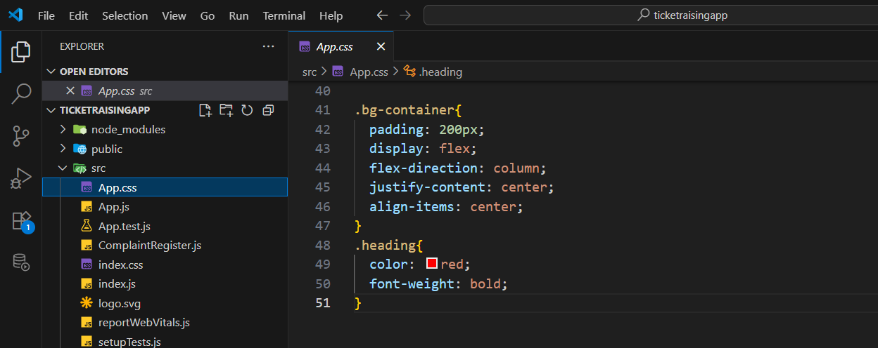

ComplaintRegister component:
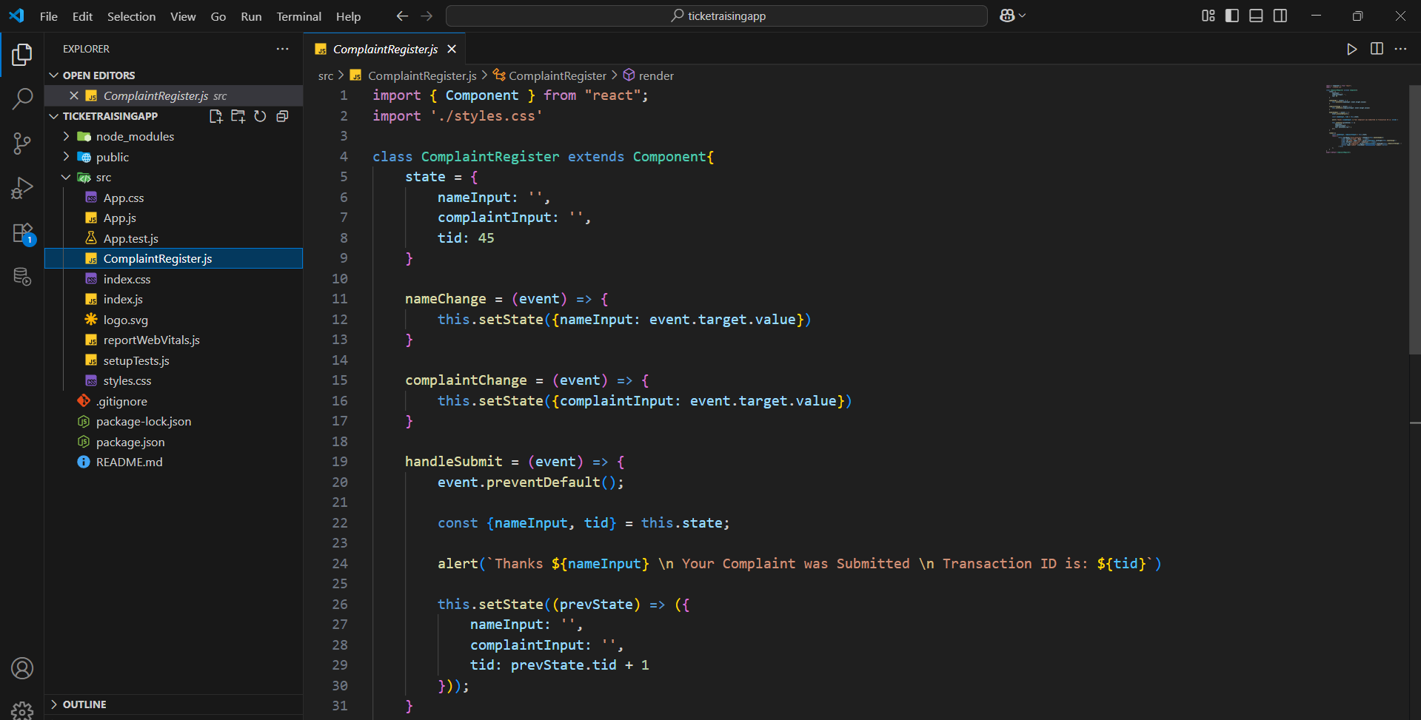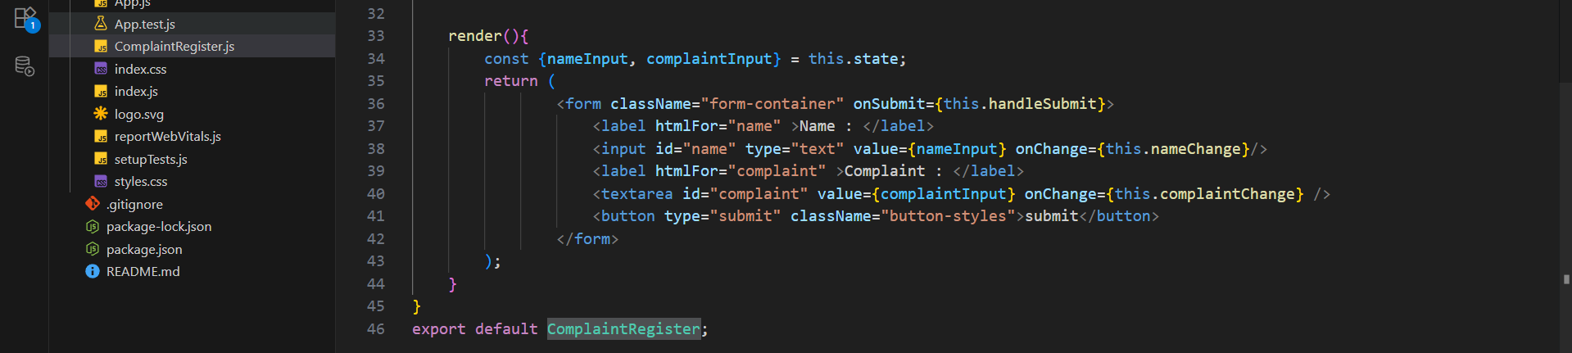
Output:
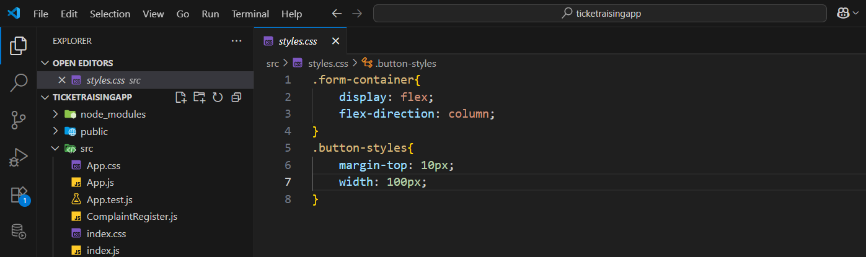

Output:
